Magic Buoy – Pontoon/Tritoon System

Table of Contents
1. Brief Overview
2. System Assembly
3. Dock Installation
4. Adjustment
5. Removal & Winterizing
6. Troubleshooting

Brief Overview
Thank you for choosing the Magic Buoy Tritoon Parker System. While the system is intuitive and easy to use, proper setup and a clear understanding of how each component functions are essential for achieving the best possible docking experience.
Please read this manual thoroughly before beginning installation or use.

System Assembly
Included Components :
- End Cap
- 4” Tube
- Angle Bracket
- 4” Tube
- Reducer Bracket
- Rock Stopper
- 2” Tube (12 foot strap attached)
- End Ring (16 foot strap attached)
- Pontoon Buoy, with 4 foot strap attached (Pontoon System) or; Tritoon Buoy, with 4 foot and 12 foot strap
Additional parts: 5/16 flat head screws (24 pcs and 2 spare), 3/16 allen key,
15” fenders, Fender fill adapter (if equipped with polyform fenders)
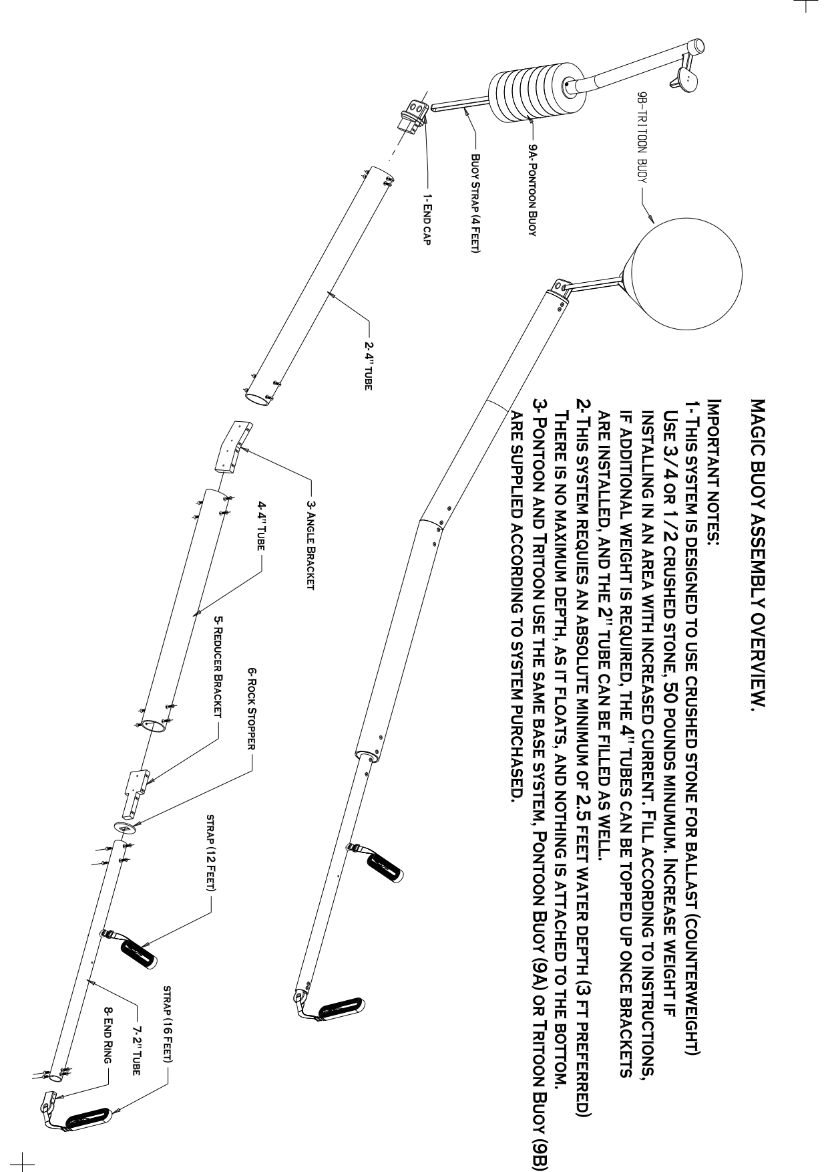
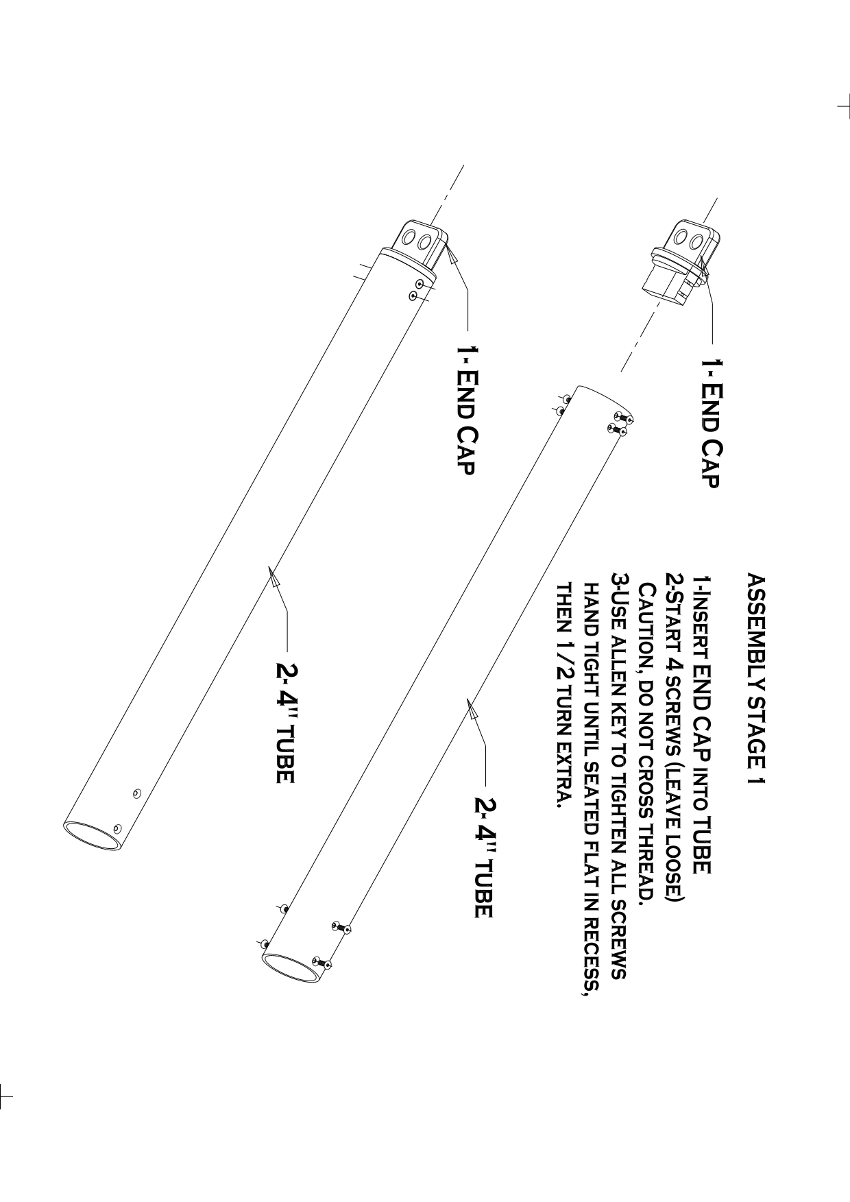
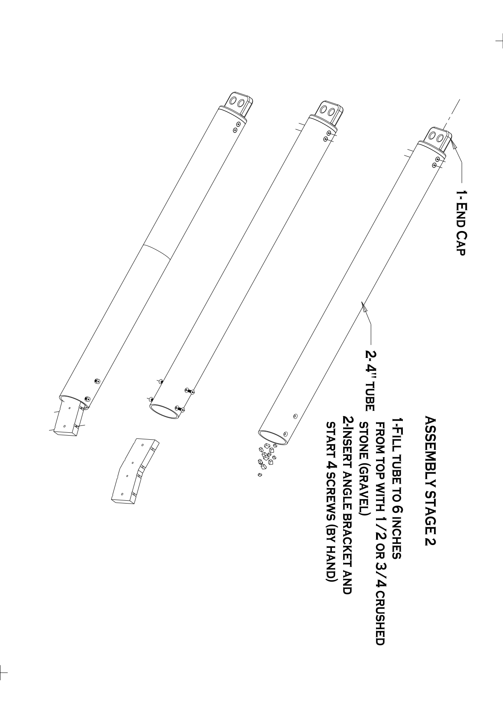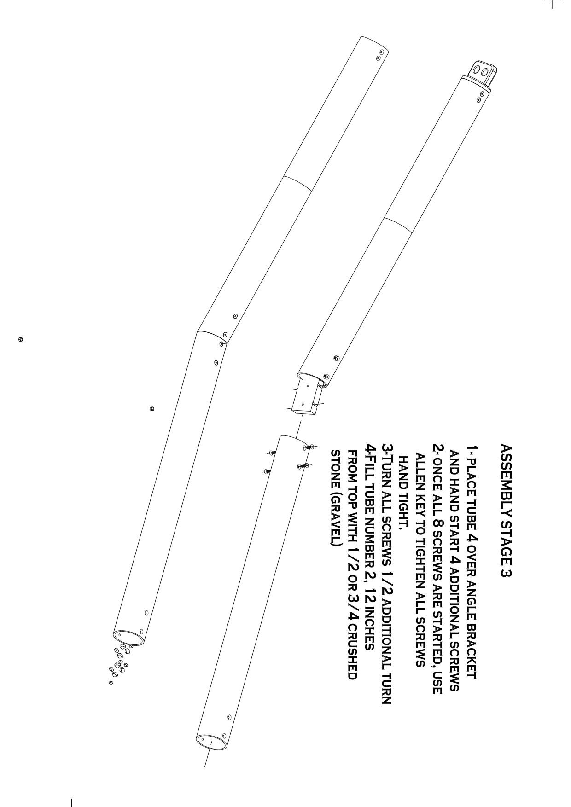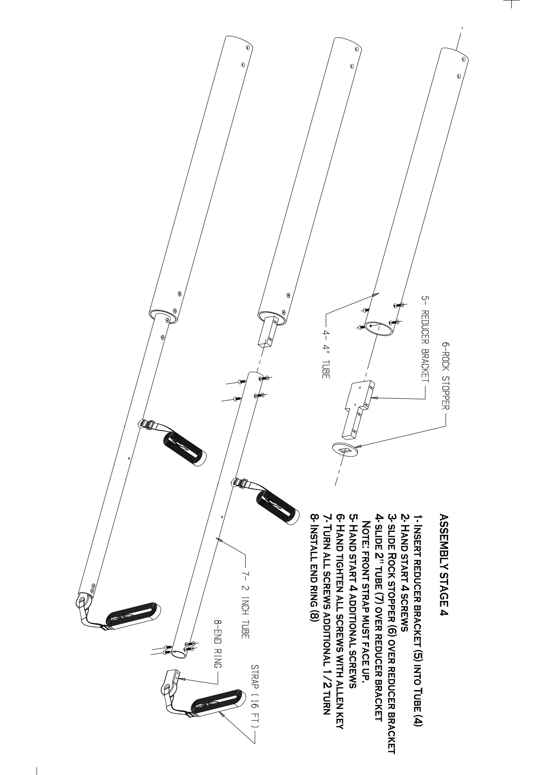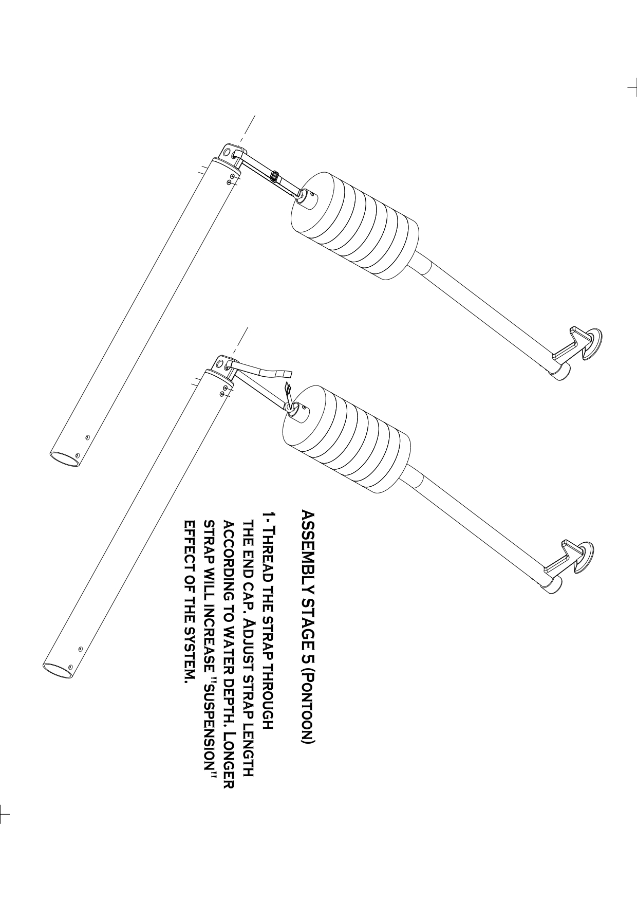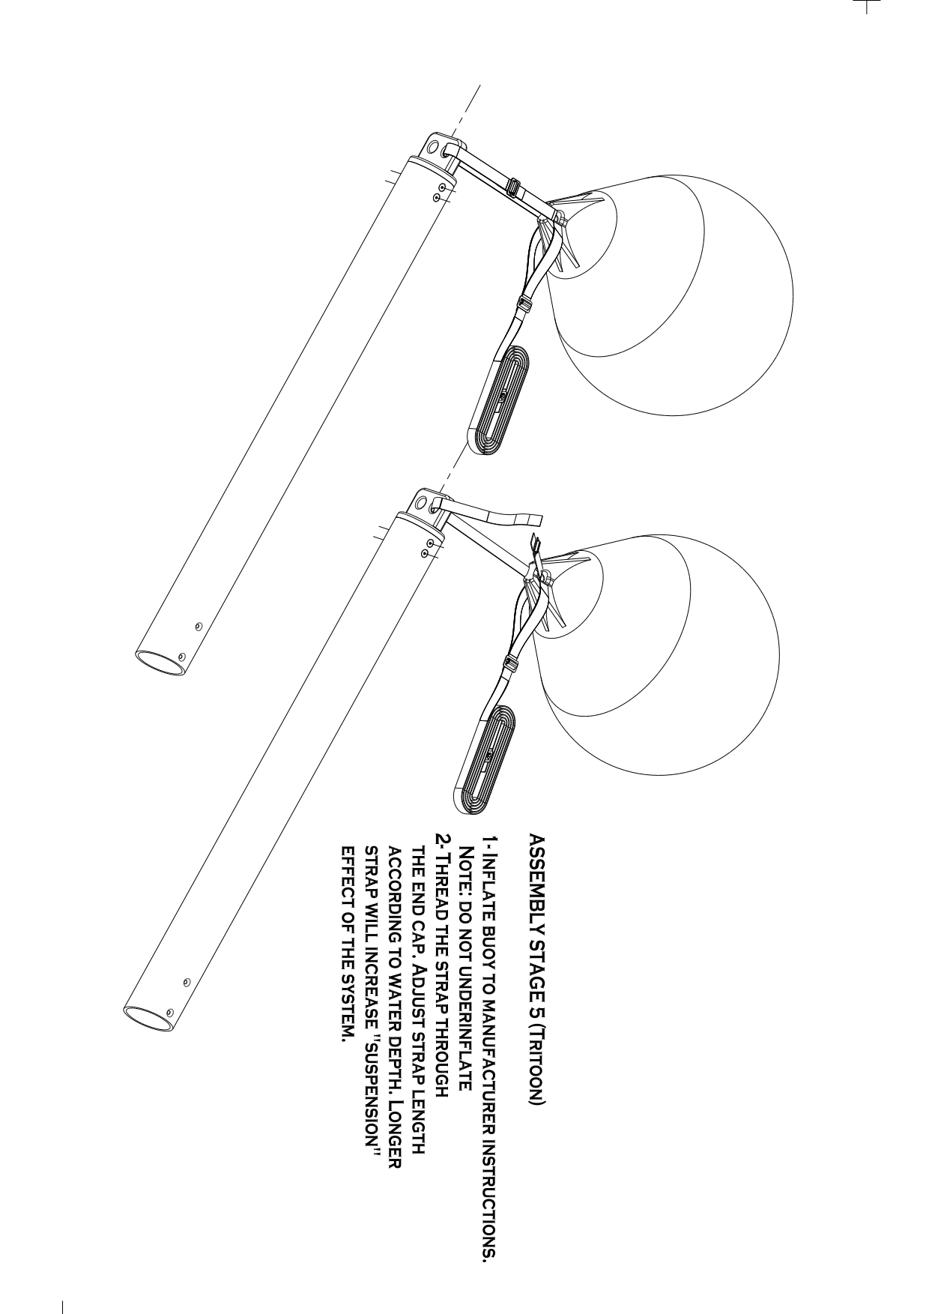

Pontoon Parker Installation and Operation (Skip to Tritoon section for Tritoon)
Strap Configuration
Boat-Side Strap
Located ~30” from the dock-end of the tube. Secure it to the dock face where the boat will be parked.
Recommended tie-off point: 10-11 feet behind the intended boat stop position.
Angle Strap
Attached at the far (dock-side) end of the tube. Route it under the dock at a 40° angle (APPROX), avoiding obstacles like chains or posts. This strap determines the system’s resting position.
Buoy Attachment
The buoy supports the far end of the tube, which remains suspended in water.
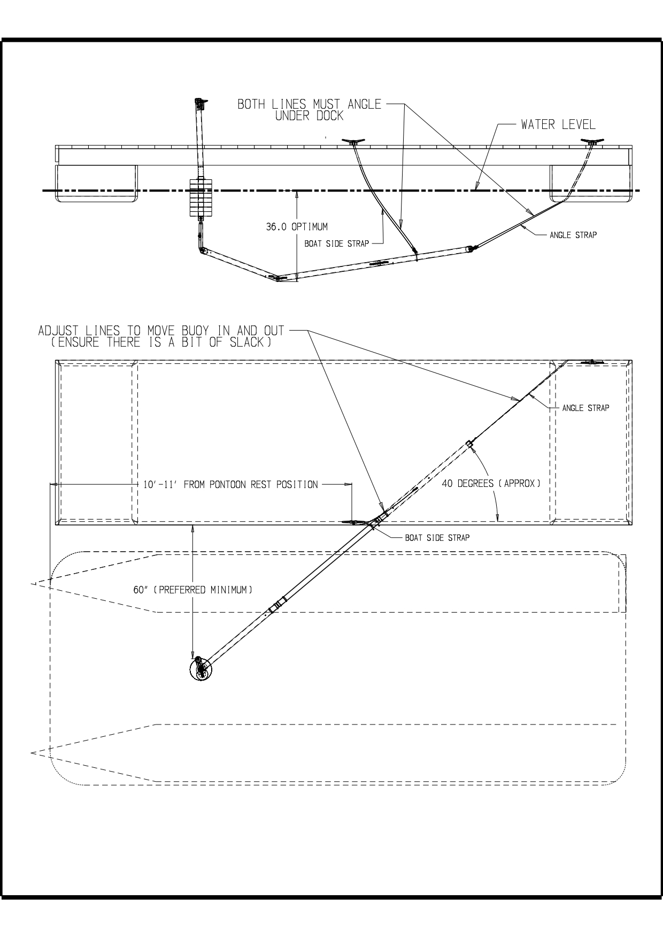

Launching the System
1. Hold both the boat-side and buoy ejection straps. Gently lower the system into the water.
2. Prevent the angle strap from falling into the water.
3. Submerge the tube until it rests 3–4 feet below the surface.
4. Tie off the boat-side strap.
5. Route the angle strap under or around the dock, avoiding obstacles, and temporarily tie it off.
6. Tie off the buoy ejection strap loosely. It should remain slack when the system is at rest.
Positioning the Buoy
While every dock and boat setup is unique, use these as baseline settings:
- Confirm boat-side strap is secure and system is submerged ~3 feet.
- Apply tension to the angle strap to pull the buoy outward from the dock.
- Aim for ~60” spacing between dock and buoy when at rest (no load).
Fine-Tuning Adjustments:
- Adjust tie-off point of the angle strap to change the buoy’s resting arc (see diagram).
- Adjust slack ratio between boat-side and angle straps to shift the system along its arc.

Fendering (Important!)
Included are two 15” fenders. These are critical to system functionality and protecting your boat and dock from damage.
Fender Placement
Position fenders especially near the bow to prevent the splash guards from hitting the dock. Adjust placement based on your boat’s configuration (see diagram).
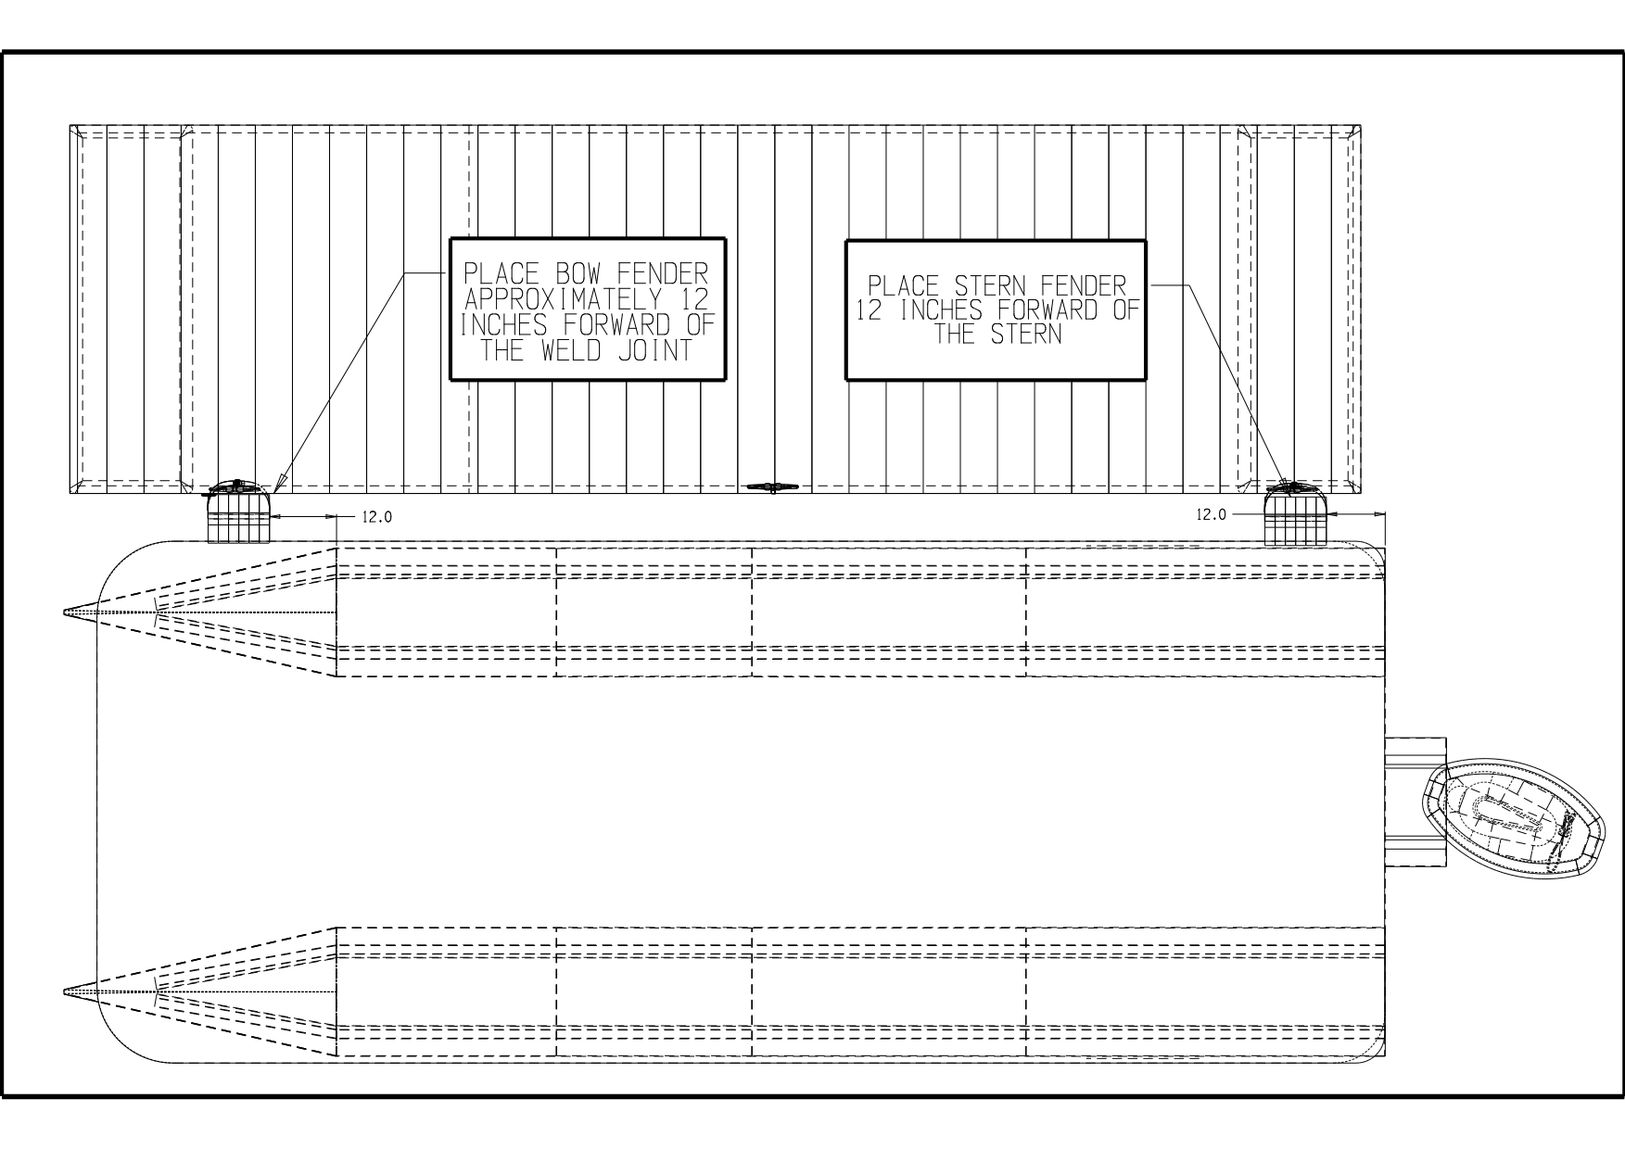

Testing & Final Adjustment
After installation:
- Conduct test dockings with help from someone on the dock.
2. Check bow clearance and adjust fenders as needed.
3. Adjust strap tensions or tie-off points as required — this is normal.
4. Once satisfied, install permanent cleats or tie-off rings on the dock.
5. Mark line positions with tape or use slide adjusters to simplify re-installation after cleaning or winter.

Docking Procedure
⚠️ Important: All maneuvers should be performed at idle speed only. Never use throttle. Excess thrust may damage the system, boat, or dock.
- Before approach: Note wind/current conditions. A flag on your dock can help gauge wind direction.
2. Approach slowly: Use forward-neutral-forward pulses to maintain low speed and control. Avoid reverse unless necessary.
3. Align with buoy: Steer to make contact with the buoy in the center of the deck. Open the bow gate for visibility (ensure passengers stay clear).
4. Coast in: Allow the buoy to tap the front deck. Just before contact, steer AWAY from the dock.
5. Engage buoy: As contact begins, shift into forward (idle) with helm turned away from the dock. The buoy will slow the boat while thrust pushes the stern in.
6. Hold position: The boat will remain stationary in gear. Crew may disembark safely. Solo users should have a safety line ready for tying off before leaving the helm.
7. After docking: Once in neutral, the boat may drift 1–2 feet backward — this is normal and should be accounted for in final system setup.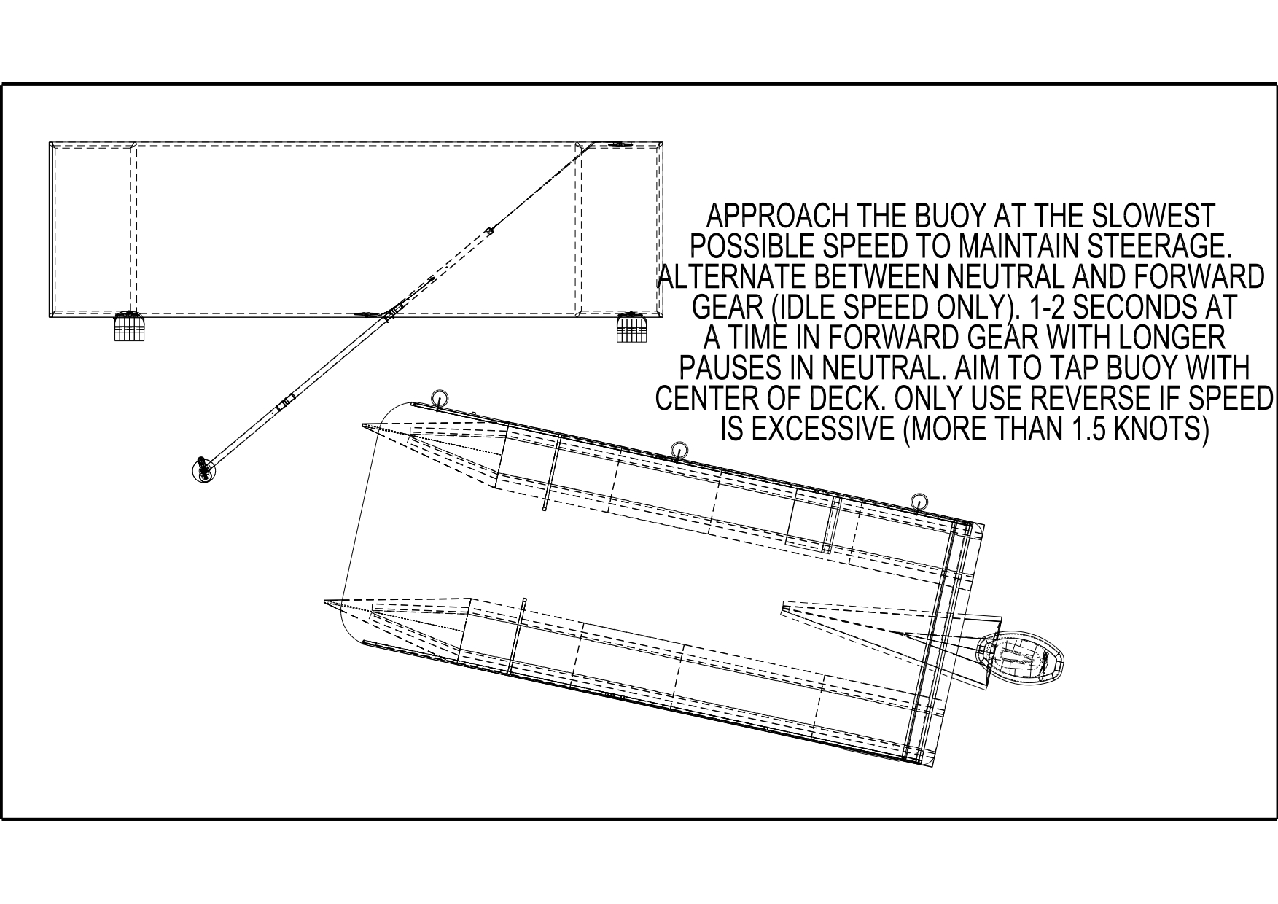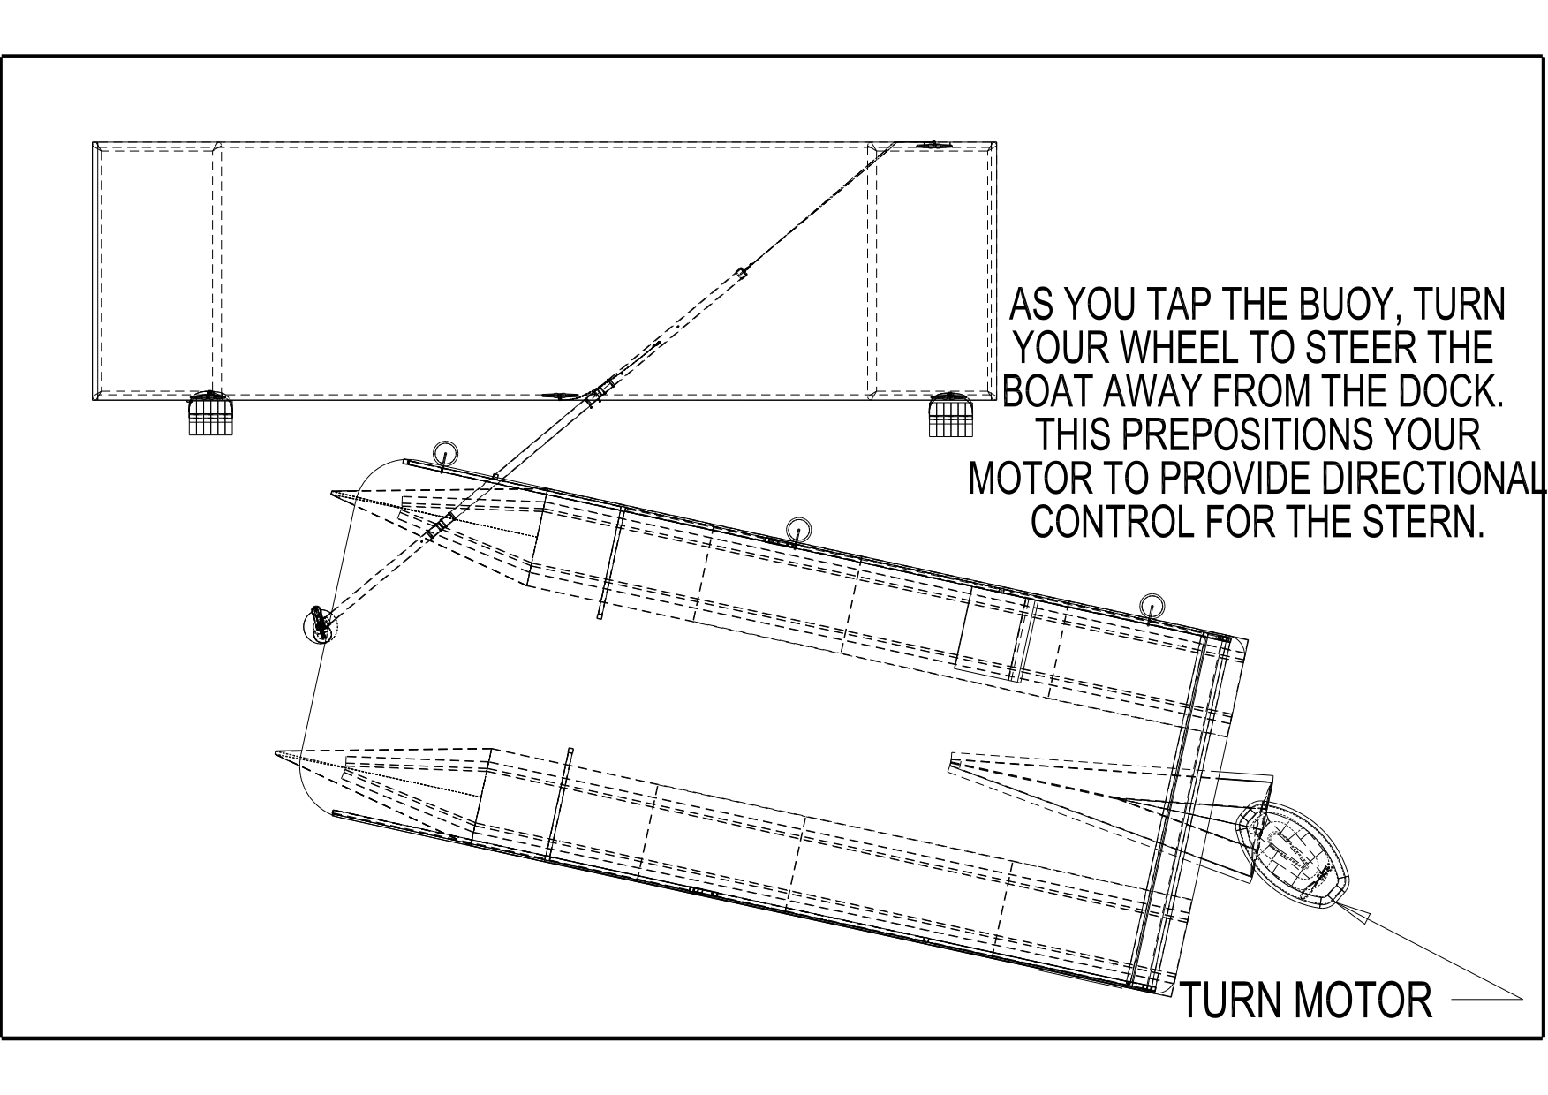
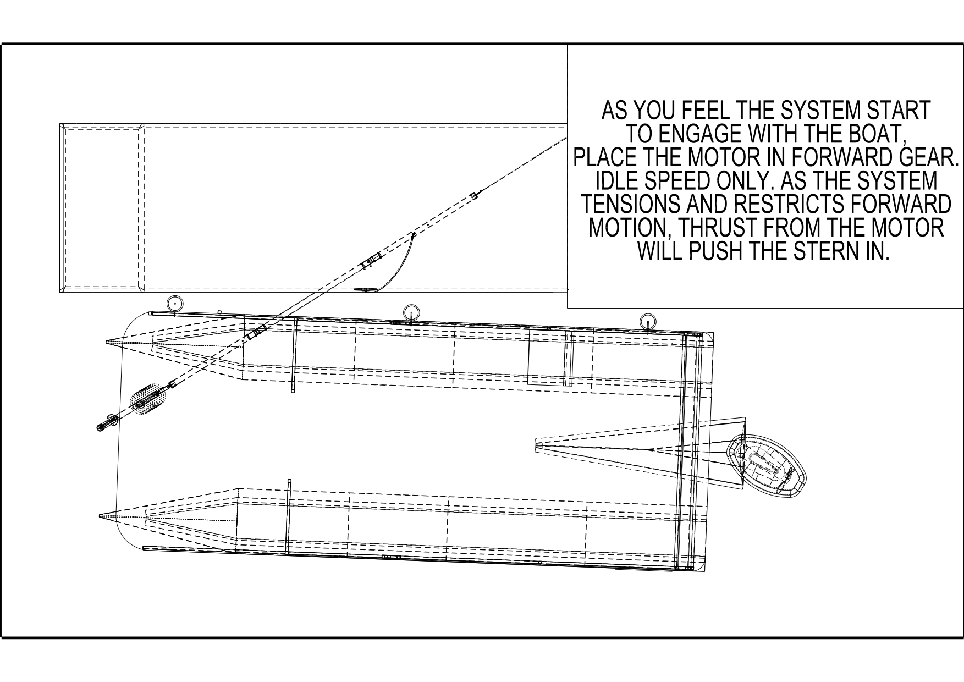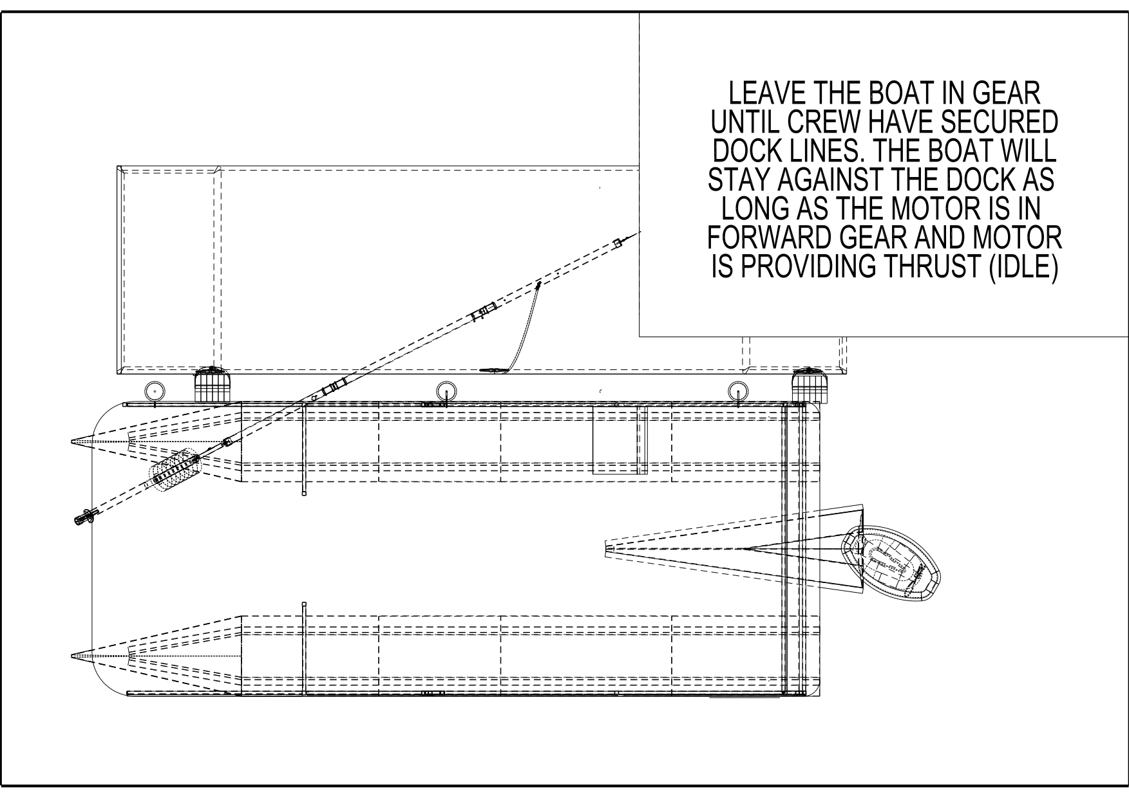

Departure Procedure
The system also supports smooth departures:
- Before untying, engage forward (idle) with helm away from the dock.
2. The system will hold the boat in place while crew unties at leisure.
3. Once ready, steer toward the dock and remain in forward (idle).
4. The buoy will hold the bow while the stern swings outward.
5. Reverse out once the stern clears. The buoy will automatically reset, ready for your next docking.

Tritoon Parker Installation and Operation
Strap Configuration
Boat-Side Strap
Located ~30” from the dock-end of the tube. Secure it to the dock face where the boat will be parked.
Recommended tie-off point: 12-13 feet behind the intended boat stop position.
Angle Strap
Attached at the far (dock-side) end of the tube. Route it under the dock at a 35° angle (APPROX), avoiding obstacles like chains or posts. This strap determines the system’s resting position.
Buoy Attachment
The buoy supports the far end of the tube, which remains suspended in water.
Launching the System
1. Hold both the boat-side and buoy ejection straps. Gently lower the system into the water.
2. Prevent the angle strap from falling into the water.
3. Submerge the tube until it rests 3–4 feet below the surface.
4. Tie off the boat-side strap.
5. Route the angle strap under or around the dock, avoiding obstacles, and temporarily tie it off.
6. Tie off the buoy ejection strap loosely. It should remain slack when the system is at rest.
Positioning the Buoy
While every dock and boat setup is unique, use these as baseline settings:
- Confirm boat-side strap is secure and system is submerged ~3 feet.
- Apply tension to the angle strap to pull the buoy outward from the dock.
- Aim for ~48” spacing between dock and buoy when at rest (no load). This insures the buoy will get caught between the center and dock-side pontoons.
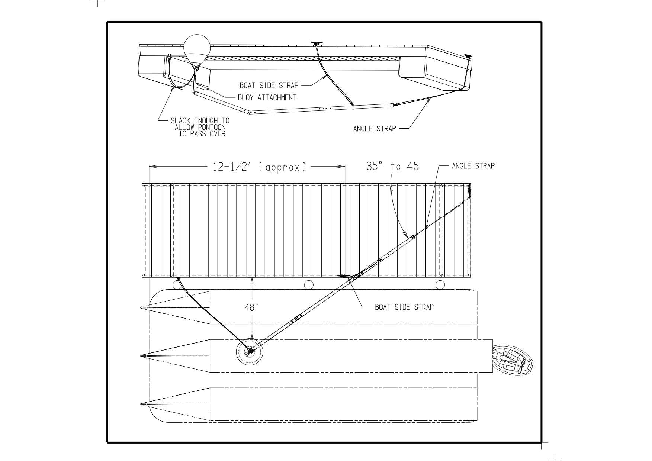
Fine-Tuning Adjustments:
- Adjust tie-off point of the angle strap to change the buoy’s resting arc (see diagram).
- Adjust slack ratio between boat-side and angle straps to shift the system along its arc.

Fendering (Important!)
Proper fendering is critical for optimal performance of the system, and to protect the boat and dock from damage.
Fender Placement
Position fenders especially near the bow to prevent the splash guards from hitting the dock. Adjust placement based on your boat’s configuration (see diagram).

Testing & Final Adjustment
After installation:
- Conduct test dockings with help from someone on the dock.
2. Check bow clearance and adjust fenders as needed.
3. Adjust strap tensions or tie-off points as required — this is normal.
4. Once satisfied, install permanent cleats or tie-off rings on the dock.
5. Mark line positions with tape or use slide adjusters to simplify re-installation after cleaning or winterizing.

Docking Procedure
⚠️ Important: All maneuvers should be performed at idle speed only. Never use throttle. Excess thrust may damage the system, boat, or dock.
- Before approach: Note wind/current conditions. A flag on your dock can help gauge wind direction.
2. Approach slowly: Use forward-neutral-forward pulses to maintain low speed and control. Avoid reverse unless necessary.
3. Align with buoy: Steer to allow the buoy to go between the dock side and center pontoons.
4. Coast in: Allow the buoy slide under the deck. Just before contact, steer AWAY from the dock.
5. Engage buoy: As contact begins, shift into forward (idle) with helm turned away from the dock. The buoy will wedge between the 2 pontoons and slow the boat while thrust pushes the stern in.
6. Hold position: The boat will remain stationary in gear. Crew may disembark safely. Solo users should have a safety line ready for tying off before leaving the helm.
7. After docking: Once in neutral, the boat may drift 1–2 feet backward — this is normal and should be accounted for in final system setup.
- 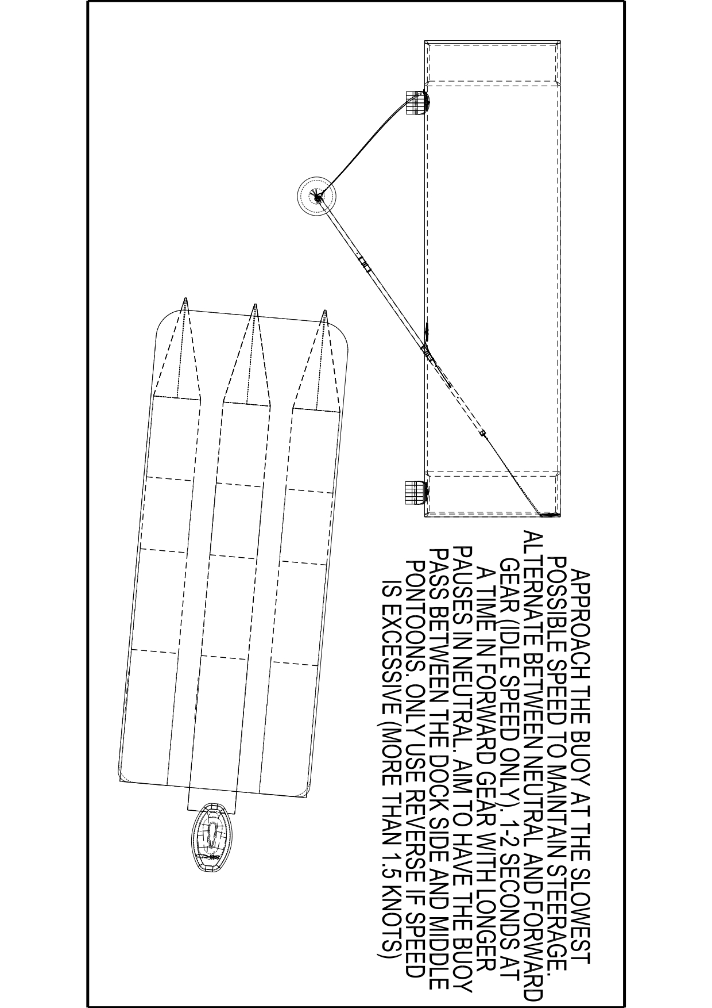
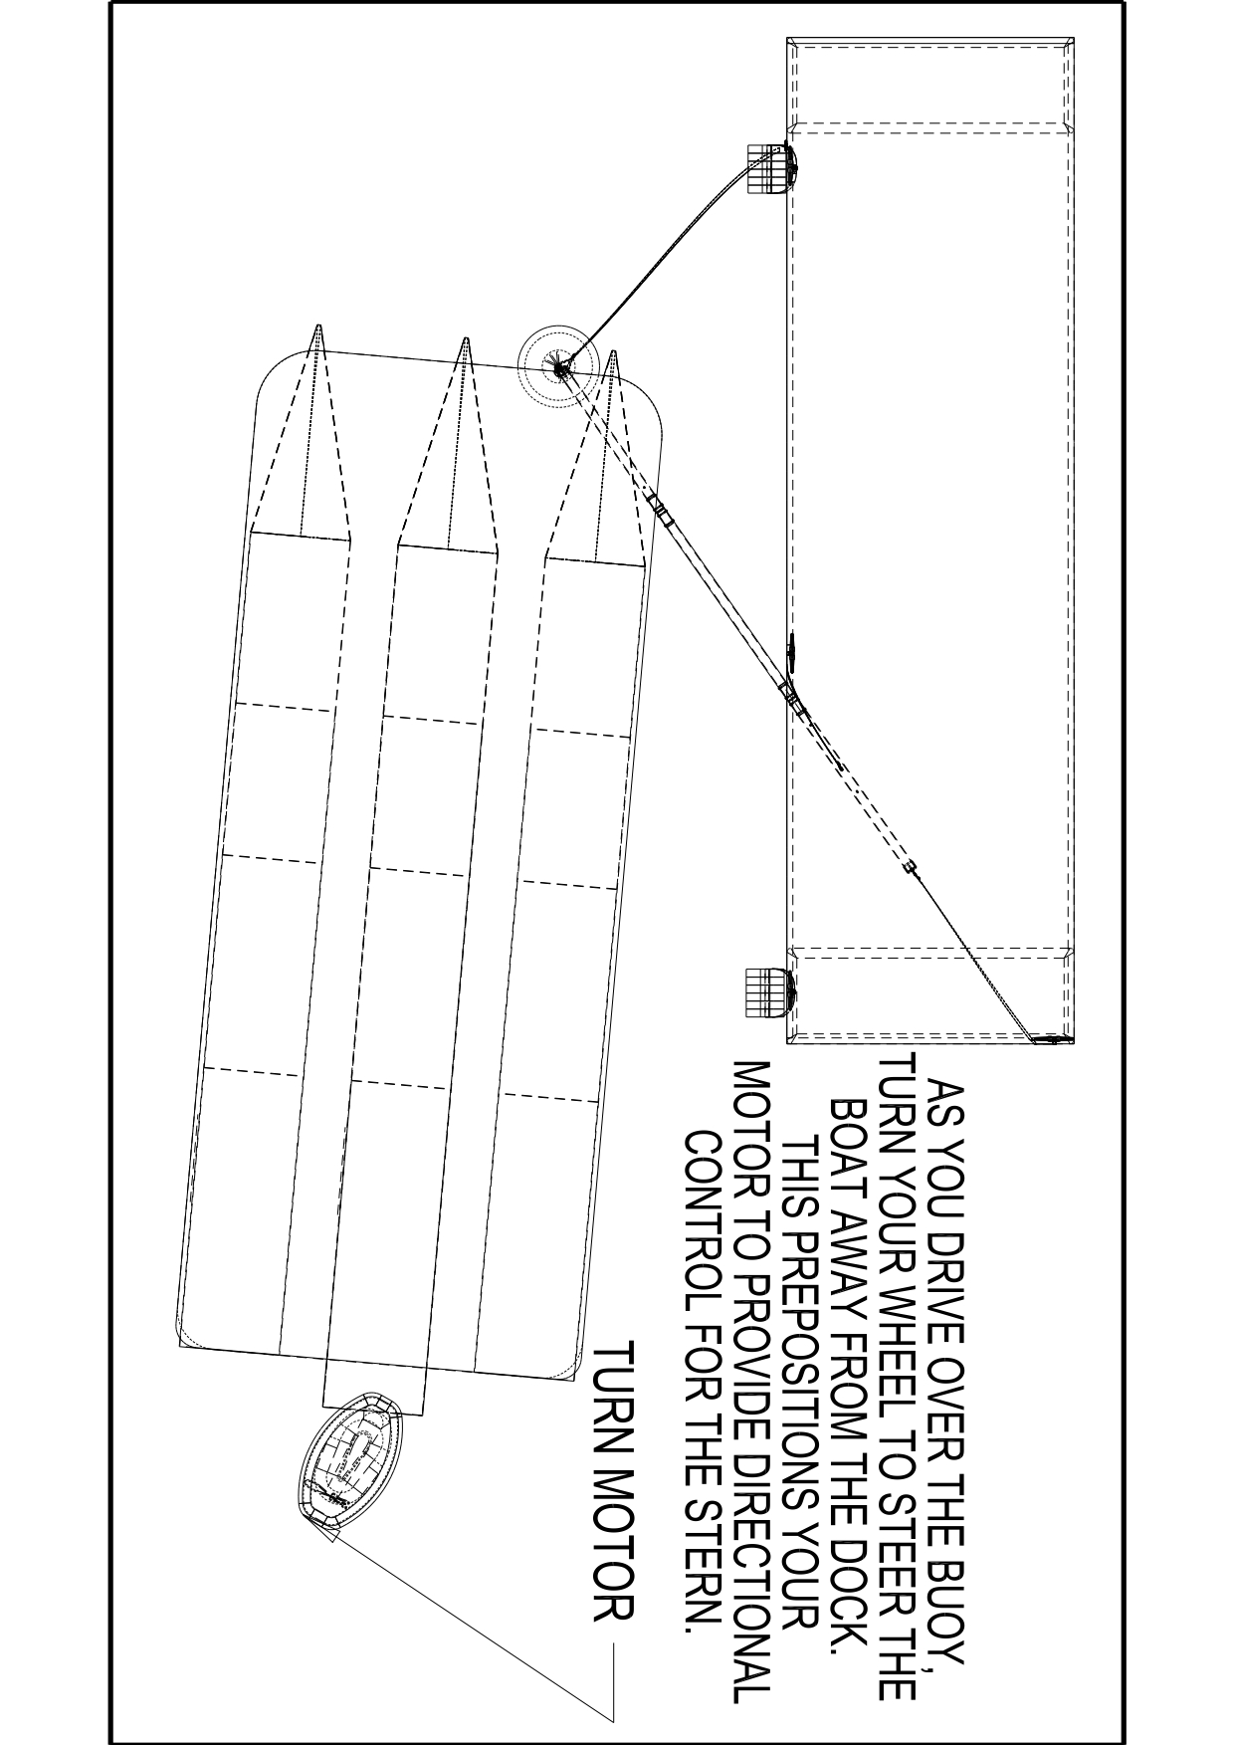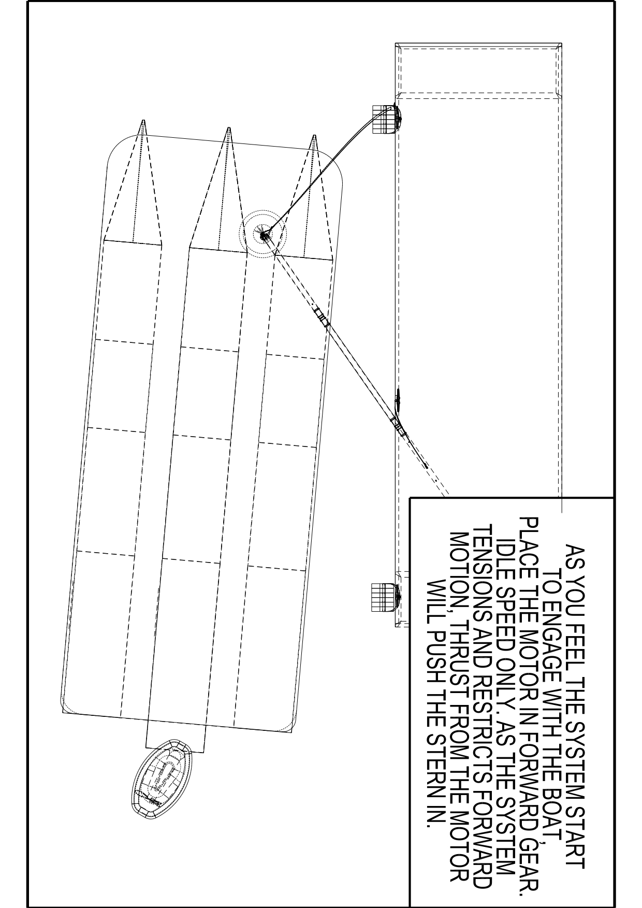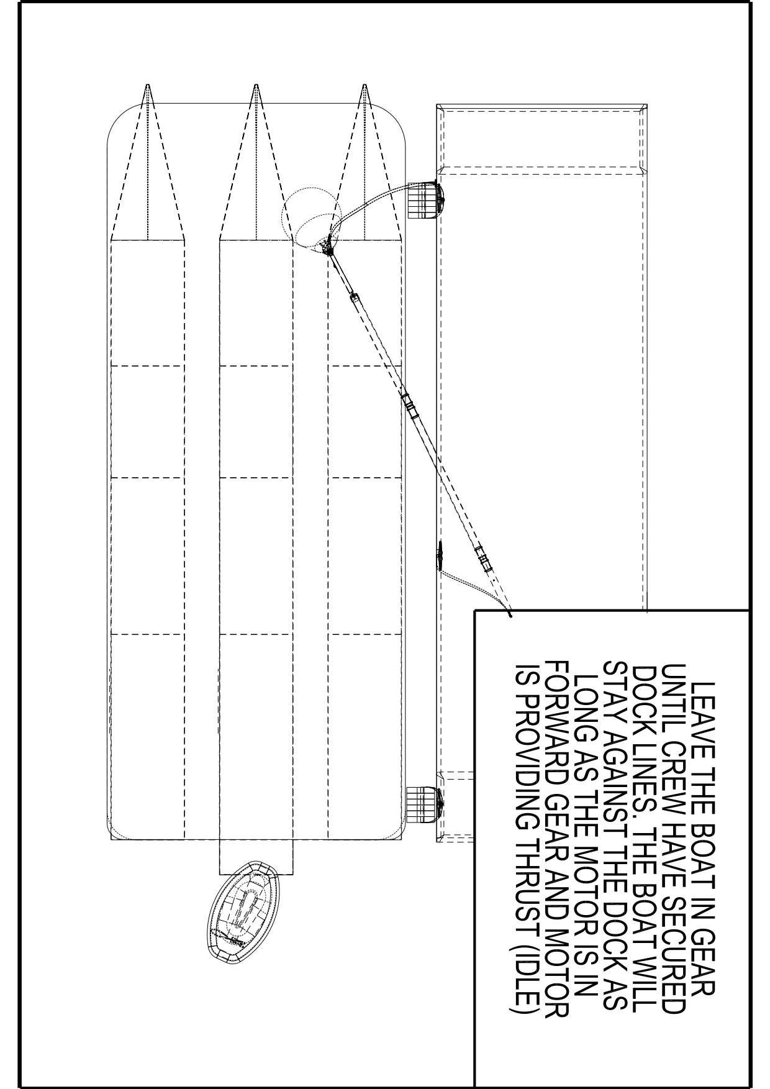

Departure Procedure
The system also supports smooth departures:
- Before untying, engage forward (idle) with helm away from the dock.
2. The system will hold the boat in place while crew unties at leisure.
3. Once ready, steer toward the dock and remain in forward (idle).
4. The buoy will hold the bow while the stern swings outward.
5. Reverse out once the stern clears. The buoy will automatically reset, ready for your next docking.

